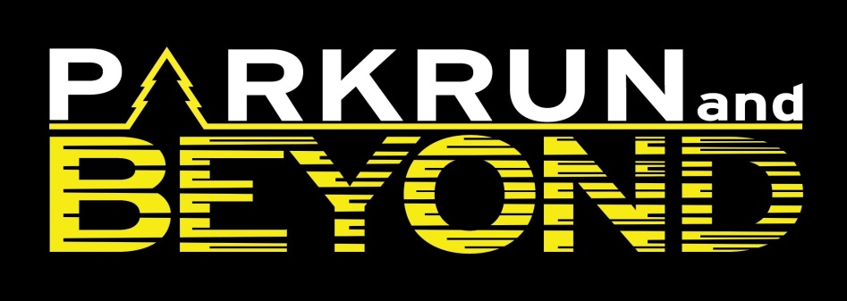

Pre-training Covid-19 health screen

Question | Yes / No | More information
Have you had confirmed Covid-19 infection or any symptoms (listed below) in keeping with Covid-19 in the last five months?  - Fever  - New, persistent, dry cough  - Shortness of breath  - Loss of taste or smell  - Diarrhoea or vomiting  - Muscle aches not related to sport/training | Yes / No | If ‘Yes’, please provide details: | Will need a medical consultation to confirm they are able to exercise.
Have you had a known exposure to anyone with confirmed or suspected Covid-19 in the last two weeks? (e.g. close contact, household member) | Yes / No | If ‘Yes’, please provide details: | Not allowed to train until they have self-isolated for 7 days.
Do you have any underlying medical conditions that you have not previously notified to the club?  (Examples include: chronic respiratory conditions including asthma; chronic heart, kidney, liver or neurological conditions; diabetes mellitus; a spleen or immune system condition; currently taking medicines that affect your immune system such as steroid tablets) | Yes / No | If ‘Yes’, please provide details: | Will need a medical consultation to confirm they are able to exercise and they are aware of the risk.
Do you fully understand the information presented in the Covid-19 Return To Training briefing and accept the risks associated with returning to the training environment in relation to the Covid-19 pandemic? | Yes / No |  | If no the information should be explained again and if they still are not aware then they should be advised not to train.

Able to train: ☐ Yes | ☐ No

Medical advice required: ☐ Yes | ☐ No

Medical advice received (attach copy): ☐ Yes | ☐ No

Name of Athlete:

Signed: |  | Date:
If under 18 parent’s signature is required: |  | Date:
Signed by Covid-19 Officer: |  | Date:

